Lab 5 Zhuoyang Chen 09/27/2019

Bifurcation analysis

1. Saddle-node bifurcation

Model:

$$\dot{x}=μ-x^{2}$$

$$\dot{y}=-y$$

Pre-bifurcation

For $μ=0.5$, I generated the quiver plot, the nullclines and the trajectories. Result is shown as below:

phase portrait from ode45 simulation phase portrait on text book (Fig. 8.1.1)

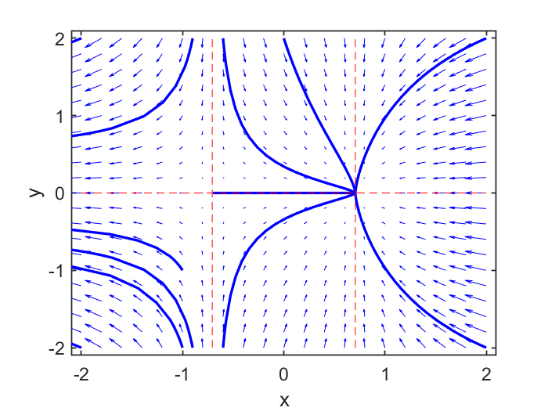 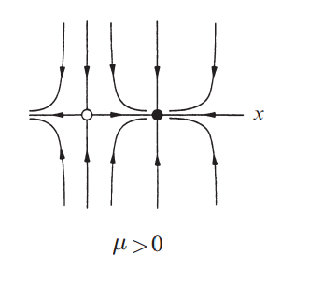

It is clear to see that there is a saddle-node on the left at $x=-\sqrt{μ}$ and a stable node on the right at $x= \sqrt{μ}$, which is similar to that in the text book. However, trajectories are not the same on both side of the vertical nullclines. They are not symmetric, the slopes are quite different.

Bifurcation

For $μ=0$, use the same approach to generate the figure above. Result is shown as below:

phase portrait from ode45 simulation phase portrait on text book (Fig. 8.1.1)

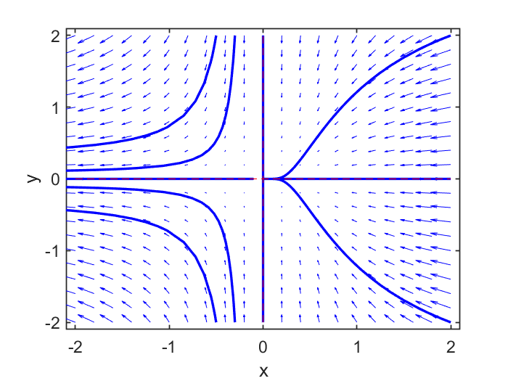 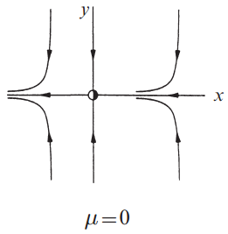

The simulation result looks the almost the same as that in the text book, except for the slight difference of the trend of slop on x > 0 region, as it is concave for the left figure and convex for the right one.

Post-bifurcation

For $μ=-0.5$, the phase portrait is shown as below:

phase portrait from ode45 simulation phase portrait on text book (Fig. 8.1.1)

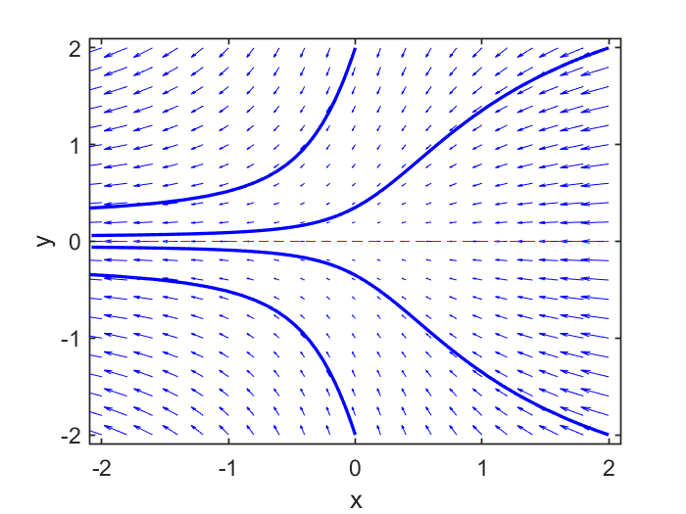 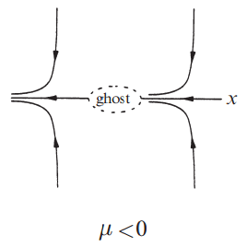

The simulation result looks different from that in the text book, as the “ghost” interupting the trajectories on the right figure is quite implicit. To clarify that, we need to further inspect what a “ghost” means. It says that “ghost” means “a bottleneck region that sucks trajectories in and delays them before allowing passage out the other side”. It doesn’t show any hints about sucking trajectories from the simulation result, but we can still check the time delay effect.

I re-generated the result using initial condition of (2, 2) and reduced the simulation time to 3.5. From the figure, we can clearly see that there is indeed a obvious time delay between t = 0.5 ~ 3. In this time span, the value of x is gradually decreasing to 0, which makes $\dot{x}$ a global minimal value, for $\dot{x}= μ-x^{2}$ always smaller than 0 and the minimum is $μ$ when $x^{2}$ is 0. The small value of $\dot{x}$ caused a slowly changing region or time delay for x, although in this case the delay time span is quite short and not obvious.

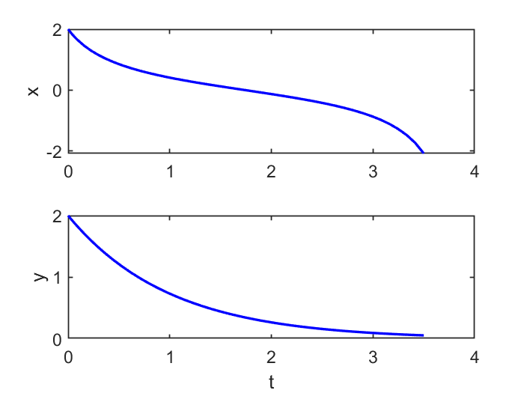

2. Homoclinic bifurcation

Model:

$$\dot{x}=μx+y-x^{2}$$

$$\dot{y}=-x+ μy+{2x}^{2}$$

Bifurcation point

In this model, I tried $μ=-1.2$, 0 and 0.1. Results are shown as below:

$μ=-1.2$ $μ=0$

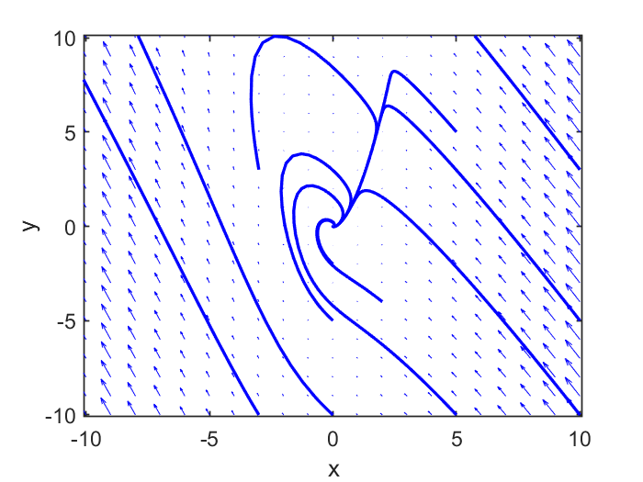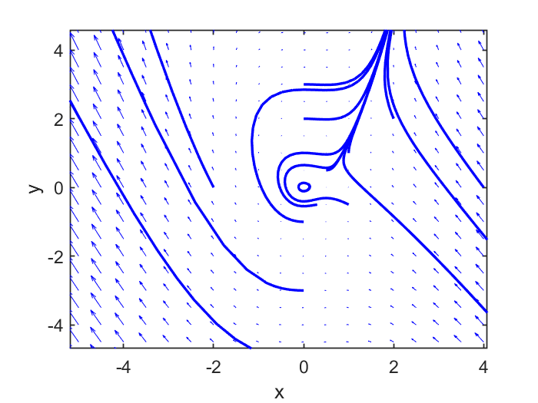

$$μ=0.1$$

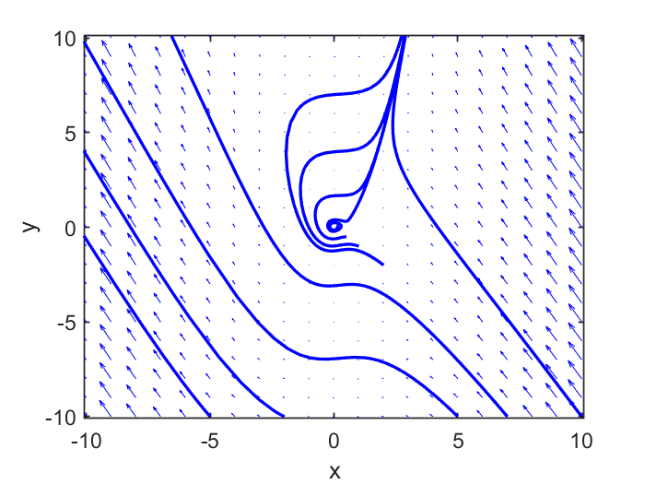

For $μ=-1.2$, fixed point (0, 0) is a stable node, but to undergo a homoclinic bifurcation, a unstable manifold of a saddle node must exist. As $μ$ is increasing, fixed poinit (0, 0) becomes unstable limit cycle, or unstable spiral. From the top right ($μ=0$), we can see a limit cycle near the origin, and when $μ$ slight increase to 0.1, the limit cycle is destroyed and become a unstable node.

To verify the bifurcation, I generated the time series plot to see how x changes.

For $μ=0$, the initial values is (0.1, 0.1), using a time span of 200. (before bifurcation)

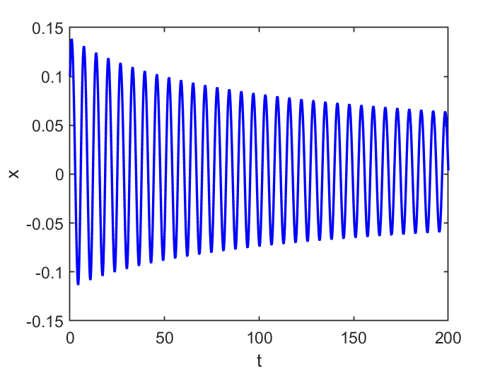

We can clearly see periods near the origin. According to the text book, we could say that a homoclinic orbit is created, as the branch of unstable manifold leaves the origin and hits it again.

For $μ=0.1$, I used the same initial values and a time span of 20. (after bifurcation)

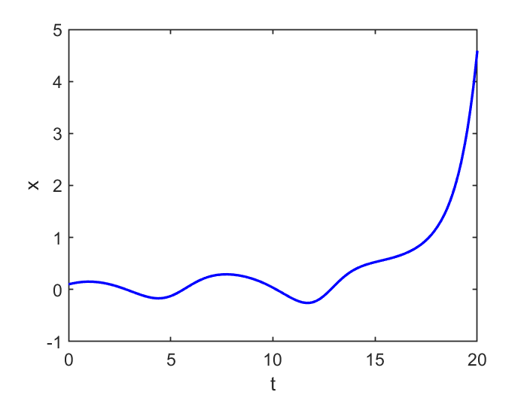

We can see that the period no longer exists and degenerates into an unstable spiral. According to the text book, we could say that after the branch leaves the origin, it is moving outside spirally and finally veers off to one side or the other.